The ABC’s of SEO

By Jonathan Wickham

Introduction

Internet usage has become pervasive in customers’ buying process for seeking out businesses and products. This evolving retail paradigm has created opportunities for small businesses to compete effectively with nation chains (brick-mortor and online) by implementing online marketing strategies, whichincrease your place in the search engine rankings. Alternatively, you may have engaged an outside firm to manage the online marketing process for you. In either case, The ABC’s of SEO is a guide designed for you. SEO stands for “Search Engine Optimization.” It is the process for helping a website move up in the search engine results so that customers can find you or your product. It is not an exact science, and no person or company can guarantee results, but this Guide will walk you through the techniques you can use to improve your chances.

The guide will teach you about SEO for organic listings and Google+ Local listings. If you do not know what these are, *do not worry*! The first chapter starts with a basic explanation of how search engines work and will define the different types of search engine results.

The first eight chapters will concentrate on how to move up in the organic listings. This will include a focus on onsite optimization, or the things that you can do to help the search engines understand what your business offers. You will be taught about “bad” elements that need to eliminated from your website’s code because they block a search engine’s processing, and you will be taught about “good” elements that need to be incorporated because they facilitate a search engine’s analysis of your site. Subsequent chapters will cover why links from other sites may help you and how to evaluate the extent to which those various links will be beneficial. The link building section will include tips and tricks for getting started, including options for outsourcing content creation and posting. The Google+ Local listings are the Google results that have telephone numbers and addresses of local businesses on a map, and these results will be explained in detail in Chapter 9 along with the steps to get listed in Google + Local. The final chapters will cover useful tools and ways to measure success.

The ABC’s of SEO is intended to teach the basics of SEO. If you get lost in the details, skip to the summaries – there is one at the end of each chapter and at the end of the book. These summaries will help you see the big picture. The internet also has articles that may help supplement the information in this guide.

Buckle up, and enjoy the ride!

Jonathan Wickham

Senior SEO Analyst

**Chapter 1: Understanding the Search Engine Landscape**

**Chapter Overview**

This chapter will layout the basic principles for understanding the search engine landscape by first explaining the elements of the search engine results page, second by outlining why indexing is necessary to appear in the results, and third by demonstrating how search engines function by evaluating a website’s own code and the code of the websites that link to it.

**Search Engine Results Page (SERP)**

A search engine results page is comprised of four main elements, which are defined below: the query, paid listings, Google+ Local, and organic listings. The strategies in this guide focus on how to increase your website's position in the organic listings and Google+ Local because customers generally focus almost exclusively on the first results page and the higher listings on the first page.

*Definitions:*

*Query* – the word or phrase that you type into the search bar

*Paid listings* – Results that can be purchased through Google’s paid search platform, AdWords.

*Google+ Local* – Unpaid listings on Google that identify the most relevant businesses in a local area and show the location of those businesses on a map

*Organic Search Results* - listings that are generated by the search engine based on the search engine’s evaluation of relevance.

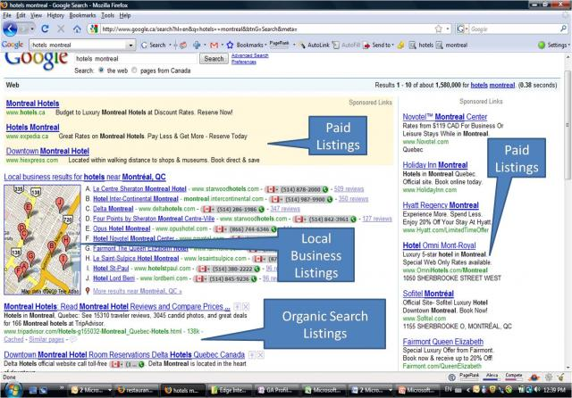

**Indexing**

A search engine is a program such as Google or Yahoo that organizes information in a process called “indexing.” The process of indexing a website can take several months for the search engine to complete. The search engine has to evaluate the data on your page to assess what the website is about, so that your website will be properly placed in the results.

An analogy helps in understanding this concept: If your webpage is a page and your website a book, then it will only be found by customers who are browsing through Google’s “library.” If you aren’t in the “library,” then your book will not be read, even though it has been written. Google has to place you in the appropriate section of the library so that your book will be categorized properly.

Google indexes your website in several stages:

1. Google finds a link to your page from another page. (Google “hears” about your “book”)
2. The Googlebot visits your page. (Google “reads” your “book”)
3. Google analyzes the data on your page and copies it into its database (Google categorizes your “book” by its exact title, but not necessarily by a topic like “science fiction.”)
   1. In this phase, you will find your website if you search by your name “myscrapbookingmaterials.com,” but not necessarily in a keyword search as “scrapbooking materials.”
4. Google shows your page in a general search and assigns you a pager rank value.

**How Search Engines Work**

A search engine is a software program such as Google or Yahoo that analyzes data. Although we personify the search engine by referring to Googlebots that “crawl” the websites, the search engine is just software and can only interpret your website by three criteria:

1) The website’s own software code (i.e. what you say about yourself)

2) Outward pointing links to other websites, (i.e. the type of friends you claim)

3) Inbound links or citations from other websites to your website, (i.e. the type of friends who claim you)

The purpose of the search engine is to display the most accurate and relevant information to your query. In general, the search engines give the most credence to the links or citations from other websites to your website (i.e. what your friends say about you). These links are the votes that determine a website’s authority (reliability) and relevance for a specific keyword.

***Chapter Summary:***

***1) Your goal is to have your business highly ranked for Organic Search Results and Google Local.***

***2) Your page will show up on a search engine result only after it has been indexed.***

***3) Search engines can evaluate your code, the links from your site to others and the links from other sites to you.***

***4) Search engines give the most weight to the links or citations from other websites to yours.***

**Chapter 2: Keyword Strategy**

**Chapter Overview**

The backbone to any successful online marketing campaign is a keyword strategy, where you consider search engine optimization in the context of your overall business plan. The purpose of this chapter is to help you understand how to select the keywords that are going to bring the right type of user to your website and convert to sales. Three metrics are helpful in this analysis: 1) keyword monthly search volume, 2) keyword competition, and 3) keyword current ranking (if you already have a website). Also, if you have not already purchased a domain name, you should consider an exact match domain, where the domain name includes the keywords you have selected.

**Effective Keyword Cluster**

A keyword is an actual word or phrase that is typed into the search engine query. Most people use lower case when typing in search terms, so it’s recommended to use lowercase keywords. Keywords are general, specific or very specific.

General keyword: “mma gear”

Specific: “kids mma gear”

Very specific: “cheap mixed marital arts gear” or “fight gear New York”

As you research keywords, consider your target customer, the location of your business, and what distinguishes your business from the competition. By using modifiers, such as “kids” or “cheap” in this example, your keywords target a smaller subset of customers, but it may be a subset that is more likely to value what your business offers.

**Exact Match Domain**

If you are selecting a domain name or purchasing a new one, you have an opportunity to choose a domain that correlates with your keywords. An exact match domain is where the exact keywords that you are targeting are in the domain name. For example, if your core business is MMA clothing and equipment for kids, you may want one of your keywords to be “youth mma gear.” An exact match domain name for those keywords would be “youthmmagear.com.” An exact match domain is an easy way to achieve higher search engine rankings, but choosing the URL is ultimately a business decision with no right or wrong answer. A branded strategy may lead to more customer recognition and overall sales. For example, a domain name of Jonathan’sMMAWarehouse.com would not be an exact match domain, but it may be more memorable to a customer if Jonathan’s MMA Warehouse is a well-known brand.

**Keyword Diversity**

You will want to choose a diversity of keywords so that they all don’t point just to the homepage, but that they target all the pages of your website. For example, if “mma gear” points to the homepage, then “kids mma gear” might point to the category page or your website, and then “Under Armor kids mma shirts” might be a keyword for your product page. A diverse set of keywords will give you a bigger footprint in the online marketing landscape.

**Monthly Search Volume**

Monthly search volume will show how many users type in a specific query on a monthly basis. There are many tools available for showing monthly search volume for keyword analysis that can be found on the internet, but Google AdWords is one that is both effective and free. The Google AdWords tool, <https://adwords.google.com/o/KeywordTool>, is meant for evaluating paid search volume, but it is useful for researching organic search volume as well. On the left of the AdWord page, you can select broad, exact or phrase. The exact search is the most helpful for keyword strategy because it is the most specific.

**Broad, Exact or Phrase Options in AdWords**

*Broad* - will encompass variations of your keyword, so for the keyword “kids mma gear,” the search volume results would include “mma gear for kids” and “mma kids gear”

*Exact* – will include only the identical phrase, so if the keyword is “kids mma gear,” then it would show the search volume for “kids mma gear” only.

*Phrase* – identical phrase, but within a larger sentence. For the keywords “kids mma gea,” this would show the search volume for the identical phrase as well as others such as “Where can I find kids mma gear?” or “cheap kids mma gear”

**AdWords Example**

The screen shot that follows is an example of how the Google AdWords screen appears:

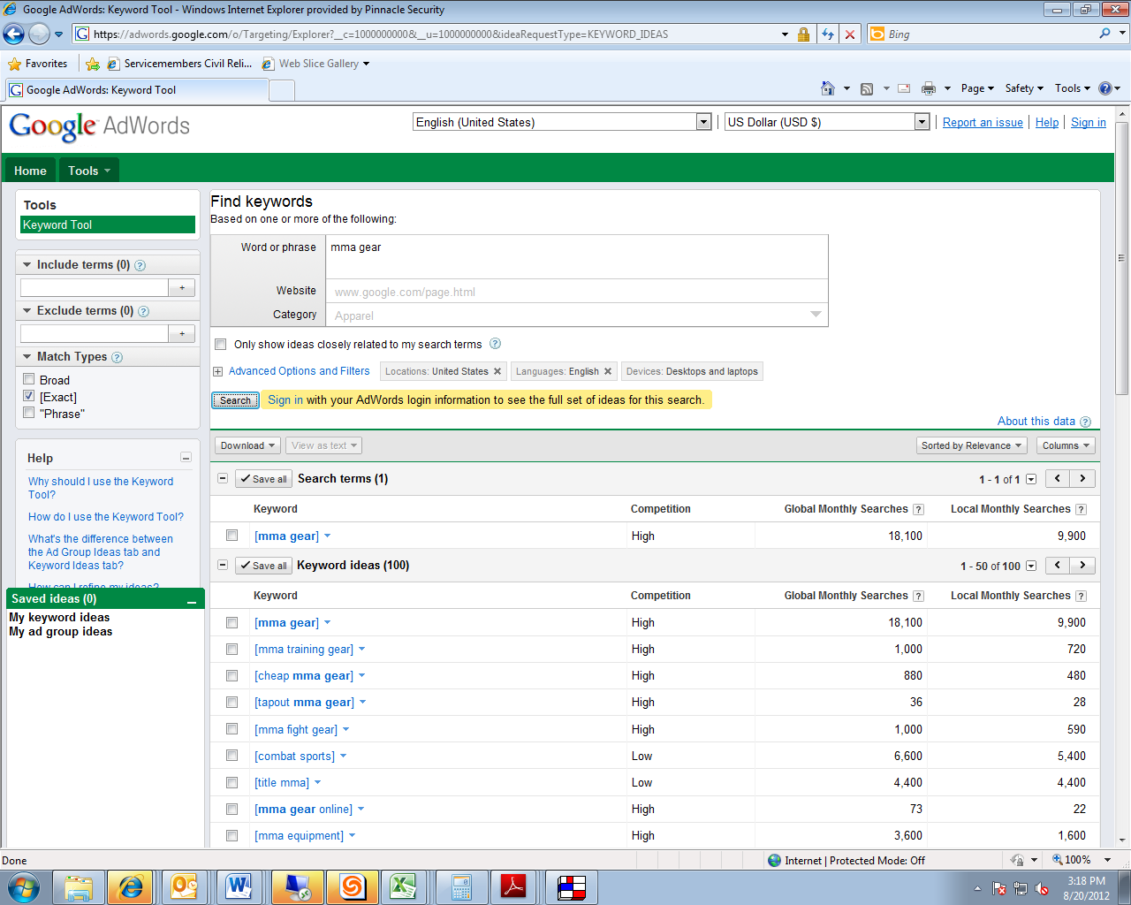

**Google AdWords Exercise:**

1. Go to <https://adwords.google.com/o/KeywordTool>
2. Select the “Exact” option on the left of the page.
3. Type in a keyword.
4. Note the number of searches as well as the search volume.
5. Consider suggested keywords down below.

**Competition**

A general keyword, such as MMA gear or kids sports equipment, will often have a high search volume because it is a more obvious search term than a specific or very detailed keyword. However, ranking for a general keyword will be difficult because competition may also be high. A good practice is to start with 10-20 keywords, with a mix of general, specific and very detailed keywords.

For example, you could have 3-4 general keywords: mma gear, kids sporting equipment, mma equipment. Then you could have some specific keywords, such as “kids mma gear,” “mma clothes for children,” “kids MMA gloves,” “fighting gear for kids,” “mixed martial arts uniforms.” Then you could have very specific keywords, such as “cheap badboy mma gloves,” “where can I find discount mma equipment for kids,” and “white compression shorts for boys,” etc.

**Current Keyword List**

If you already have a website, you will want to see what keywords you already rank for because you may want to build on the keywords that are already inherent in your site. You can look up Spyfu.com to see what keywords you are ranking for, but keep in mind that the information on where each keyword ranks on Sypfu.com is not entirely accurate. This data is dependable for showing *which* keywords you are ranked for, but not *how highly* you are ranked. To determine how highly you are ranked, a better tool is rankchecker.com.

**Spyfu Example – Which keywords are ranking**

In the screenshots below from spyfu.com for the website youthmmagear.com, you can see that the website is ranking for the keywords “youth mma gloves,” “youth mma gear,” “youth tapout shorts,” etc.

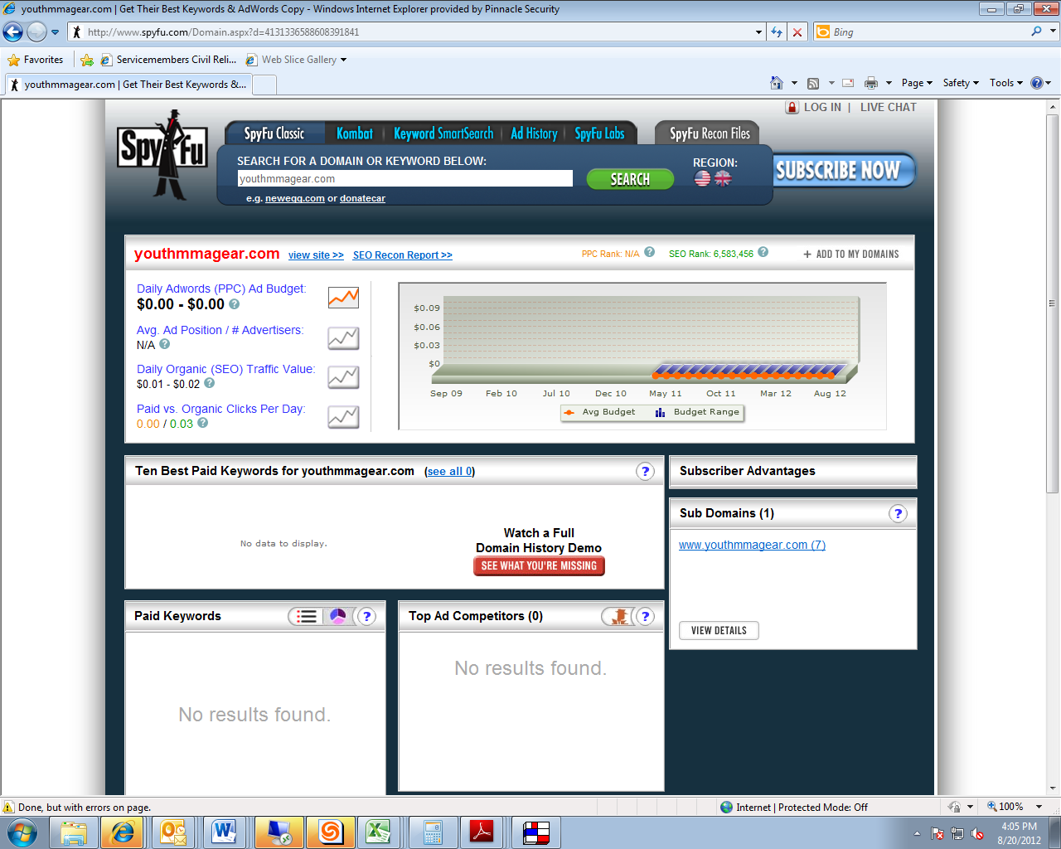

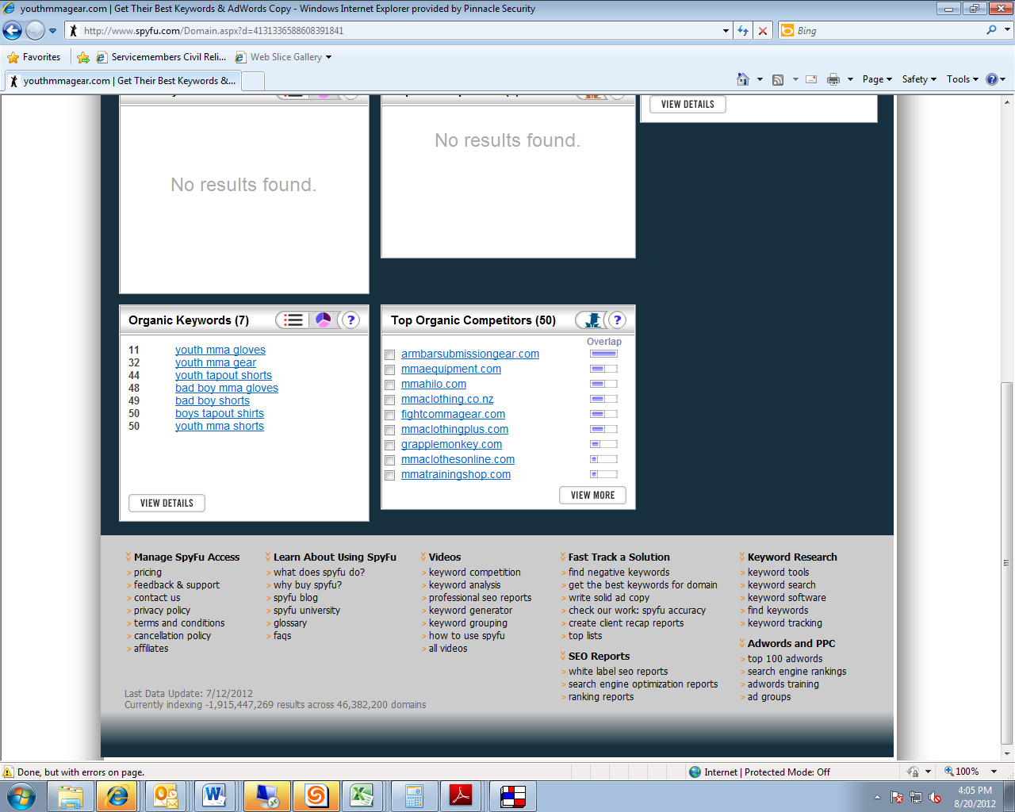

**Keyword Ranking**

From the Spyfu.com list of keywords, you can check your placement for each keyword by going to rankchecker.com and selecting the “keyword rank checker” option.

**Rankchecker- How highly your site is ranked for keywords.**

In the screenshot below, you will see that youthmmagear.com is in the top 10 ranking for the keyword “youth mma gloves” on Google.

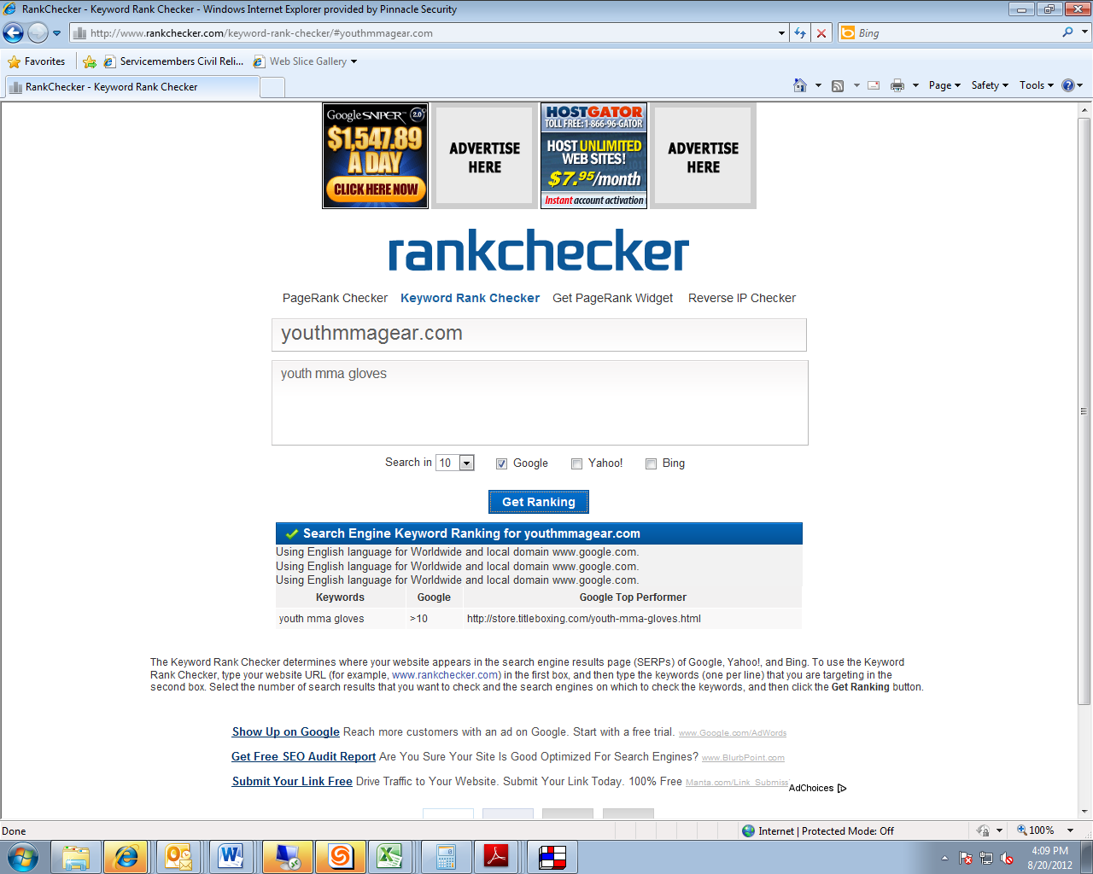

***Chapter Summary:***

1. ***Your goal is to select a mixture of keywords that will point to various pages of your website.***

***2) A high search volume means a lot of people are using that term, but high competition indicates that it will be difficult to rank for that term.***

***3) Data to help you decide the best keywords to target will include the monthly search volume (using AdWords), competition (using AdWords), and your current keyword ranking (using Spyfu.com and Rainchecker).***

***4) If you are purchasing a domain name, consider an Exact Match Domain, where the domain matches keywords.***

**Chapter 3: Onsite Optimization**

**Chapter Overview**

Onsite optimization is the easiest place to start because it involves making changes to the code and content of your website, which is in your control and does not depend on the cooperation of others. A general principle that you should remember is that repetitive, overuse of your keywords will not increase your ranking and will likely result in penalties from the search engines. The content of every aspect of your webpage, from title tag, meta description, and general content should be well-written and organized with the purpose of informing and motivating the reader/customer. There are pieces of code that can be used to identify or highlight this content for the search engine, including title tags, meta description tags, image tags, and heading tags. When creating these tags, keep in mind the recommendations in the main body of this chapter relating to length and keyword density. A clean URL structure will also be beneficial to the search engines in appropriately indexing your content. Internal links in your website point from one page of your site to another and assist the reader in navigating your site and finding the right information quickly. Internal links should include the exact keywords you are targeting.

**Avoid Keyword Stuffing**

Keyword stuffing is when the keyword is repetitively used in the visible content or in the code that is not visible to the searcher. In the past, search engine ranking could be improved by keyword stuffing, but currently it will not only NOT improve your rankings, but may result in your site’s ranking being PENALIZED by the search engine. The sections that follow will give more specific guidance as to how to avoid keyword stuffing.

**Title Tags Defined**

Title tags are one of the easiest and most important places to optimize your website for key words. The title tag is a piece of code in HTML where you tell the search engines what the page is about, and the code looks like this:

<head>   
<title>Example Title</title>  
</head>

Each page of a website has a title tag, so a title tag is like the title of each “chapter” of your website “book.” The title tag shows at the top of the website and it is the bolded, underlined, clickable link in search engines.

**Example of a Title Tag**

For example, in the screenshot below, “MMA gear-MMA warehouse” is a title tag.

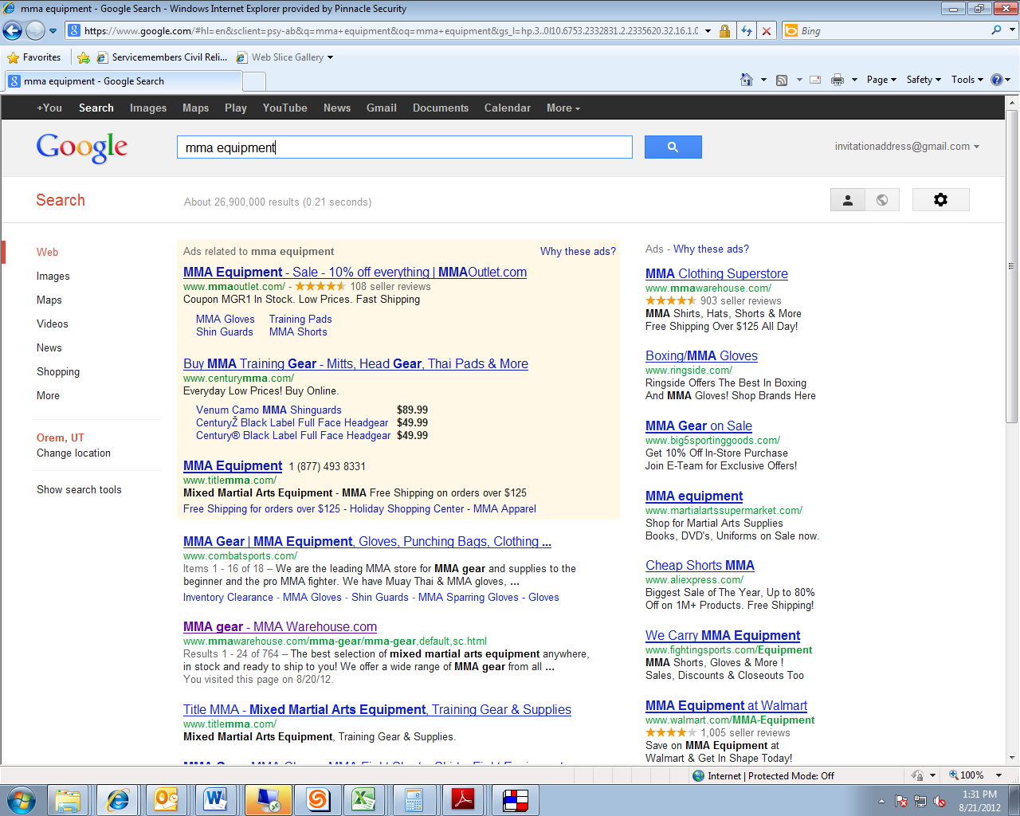

**Title Tag Best Practices**

The list below contains best practices for writing title tags, but keep in mind that Google can arbitrarily rewrite any title tags. If the Google algorithm determines that your title tag too short, keywords stuffed, or too similar to other pages on your site than Google can rewrite your title tag with other phrases drawn from your site. Well-written title tags that follow these principles are less likely to be rewritten by Google and are more likely to be effective in drawing the potential customer’s attention.

*Length* - The length should be **65** characters or less. Longer title tags will be truncated with an ellipsis and may be more likely to be re-written by Google.

*Keyword Front-Loading* - The title tag should contain keywords and the primary keyword should be placed at or near the beginning of the title tag.

*Value Proposition* - A title tag that contains a value proposition may catch the searcher’s eye. Examples: free shipping, x product from $29.99, free consultation, etc.

*Customized* - Do not write the same title tag for every page on your website. Customize the title tag for each page so that the title tag is relevant to the content.

*Succinct* - Do not include filler words such as “and,” “or,” etc. Use punctuation marks such as commas or ampersand symbols to separate topics.

*Phone number -* For local businesses, it is strategic to put the phone number in the title tag because you may convert business from the search results page and because it will help your listing in Google Places.

*Avoid keyword stuffing* - The title tag should contain no more than two or three variations of keywords and should not contain the keyword repetitively. An example of keyword stuffing, i.e. what NOT to do follows: MMA-MMA Gear- Great MMA Gear- MMA Gear For U! Better title tags would have a variety of words, such as “MMA Gear- Equipment, Gloves, Punching Bags.”

**Meta Description Defined**

The meta description is the description of the webpage. It typically displays under the title tag, although, as with title tags, Google can rewrite the meta description. When the search keyword matches the search query, it is in bold font in the search results. The code of a metatag looks like this:

<head>   
<meta name= “description” content=”this is where meta description goes.”>  
</head>

**Meta Description Example.**

In the example below, the meta description for MMA Warehouse.com is, “The best selection of mixed martial arts equipment anywhere, in stock and ready to ship to you! We offer a wide range of MMA gear from all…”



**Meta Description Best Practices**

The meta description does not influence Google’s ranking algorithm, so a well-written meta description will not move your page up in the rankings. However, the meta description is key to attracting customers and click-through rate will be significantly influenced by the content of your description.

*Length* - The length should be **160** characters or less.

*Marketing* - The meta description should be readable and compelling.

*Unique* - The meta description should be unique for each page of your website.

*No Quotes -* Don’t use quotation marks in your meta description. Use single quotes instead.

*Avoid Keyword Stuffing* - The keywords are bolded in your meta description when they match the query. Keywords may be incorporated but they should appear naturally and not be repetitive or out of place.

**Meta Keywords (Low Importance)**

Both meta descriptions and meta keywords are metatags. A meta description tag code looks like this, <meta name= “description” and meta keyword looks like this, <meta name= “keyword”

Meta keywords will not be discussed in depth, as they are not a critical factor in search engine optimization. Because they do not influence Google’s ranking algorithm and they are not seen by the customer, and the only main advice with respect to meta keywords is that if your page has them, make sure that you avoid keyword stuffing.

**High-Value Content**

Unique, quality content is one of the most important steps in optimization. Google can evaluate user-performance as part of the ranking algorithm, so that factor can cut against you if users leave your website quickly, or help you if users stay on your site.

*Image Tags -* Google’s algorithm can’t “see” an image or video as a person can see it. However, Google can interpret the Alt Image tags. These tags were originally created to assist blind users by describing the content of the images on a webpage. You can create Alt Image tags that accurately describe the image while also including keywords.

*Updated and quality content* - Your website should be updated with new content on a regular basis, and the content should be useful. Blogs are an effective means to accomplish this and will be discussed in greater detail in Chapter 9.

*Avoid Copyright Infringement* - Google will remove pages where a valid copyright infringement notice has been served.

*Avoid Keyword Stuffing* - Keyword density should be no greater than 5-6% of keywords.

**Organizational Structure – Heading Tags and Clean URL**

Content on your webpage should be organized with topics and subtopics and tags can show this organization to the search engine crawlers. To the reader, you might signal this organization through different fonts, layout, etc. The way you signal this organization to Googlebots and other search engine crawlers is through heading tags, also called H1, H2, etc. Although these tags are not a necessity, they are another way to help guide the search engine analysis of your content.

*Heading Tag Example* - If the keywords are “kids mma gear” and “martial arts equipment,” you can incorporate these into a heading that appears natural and relevant: Heading (H1) could be “5 Tips for Moms about Kids MMA Gear and Finding the Right Equipment for your Children.”

**Clean URL**

A clean URL structure is another organizational method of improving your chances of high optimization. A URL that is long or nonsensical is clearly less easily interpreted by the search engine than one that is clean and has keywords.

*Bad Example* - youthmmagear.com/5839583/83853

*Better Example* - youthmmagear.com/shirts/shirt-xt904

*Best Example* - youthmmagear.com/shirts/red-shirt

**Exact Keywords in Internal Links**

An internal link is a hyperlink from one page on a domain to another page on the same domain, so essentially your reader can click on one page of your website and it will send that person to another page on the same website. Internal links are useful for giving your reader a good user experience because they can efficiently navigate your site. They are also helpful in promoting an efficient web engine crawl, which of course, is a factor in ranking.

The code of an internal link looks like this:

<a href="http://www.anotherpagesamedomain.com/" title="Keyword Text">Keyword Text</a>

When creating internal links, you want to use your exact keywords in the clickable link. For instance, if a website is targeting the keywords “litigation funding services,” then it is better to use that exact phrase in the internal link, rather than a similar phrase that may not be a target keyword, such as “lawsuit money.”

**Example of Exact Keywords in Internal Link**

An illustration of using exact keywords in an internal link is displayed in the screenshot below. The link is “Read the stories of clients who have used LawCash litigation funding services.” The reader who clicks that link will go to a different webpage on the [www.lawcash.net](http://www.lawcash.net) site. The internal link uses exact keywords in that “litigation funding services” is in the link.

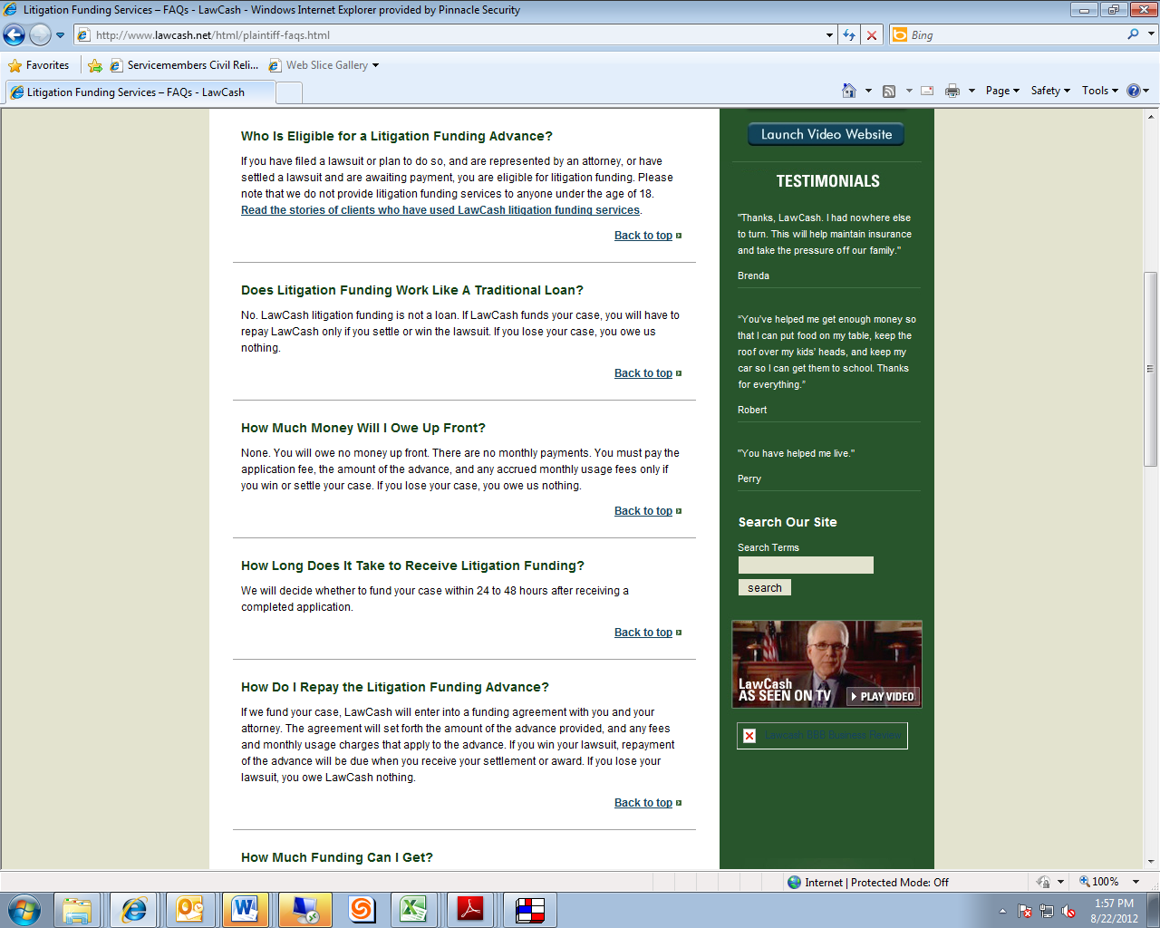

***Chapter Summary:***

***1) Do not keyword stuff (less than 6% keyword density in main content).***

1. ***Title tags should be short (<65 characters), keyword front loaded, and include phone number if target market is local.***
2. ***Meta description – 160 characters and compelling***
3. ***Create high-quality content – Updated, quality, original content***
4. ***Include organizational helps – Heading tags, clean URL’s***
5. ***Create internal links with exact keywords***

**Chapter 4: Ensuring Your Website is Indexed**

**Chapter Overview**

If a page of your website is not in the search engine’s index, the page is never going to be found through an organic search, so you want your page to be as index-friendly as possible. The beginning of this chapter will show you how to obtain an estimate of where you are by checking how many pages have been indexed. It will help you understand how to use page inclusion techniques, i.e. a sitemap and robots.txt, to encourage the search engine to index your website. Most importantly, the final section will explain page exclusion barriers that must be removed to ensure that the search engines are not blocked from indexing your site.

**Evaluating a Website’s Index**

The most common way to check indexing is by going to the search engine and writing “site” in front of the domain in question. This method is not exactly accurate, and the same search may return varied results in the same day or even hour. However, it is a fast and simple way to get an estimate of the extent to which a domain is indexed, and you can track this estimated data over time.

**Example of Evaluating a Website’s Index:**

1) To evaluate the indexing of youthmma.com, go to google.com

2) Type *site: youthmma.com*

3) You will see the number of total indexed pages right below the search area. Under the Google logo, the term “Search” is in red, and the total index pages result is in grey across from Search. In this example, the number of indexed pages on the root domain youthmma.com in Google is 225.

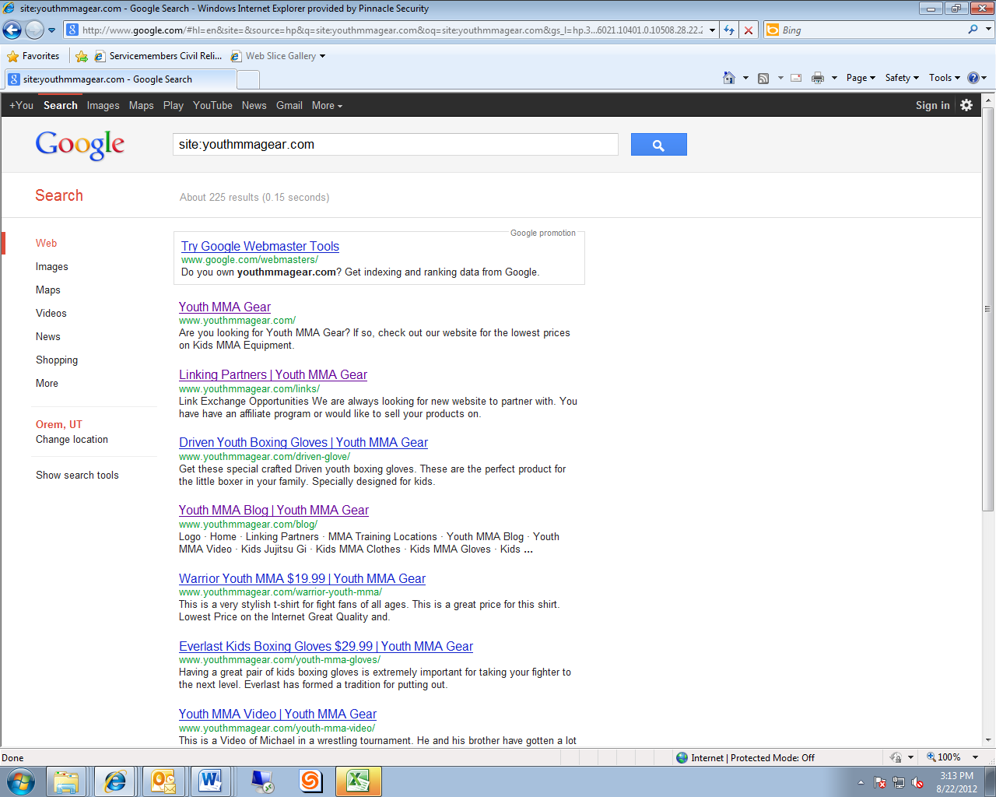

**What is Robots.txt**

The Robots.txt is the first place the search engines go when they start to read the code on the page. The Robots.txt will tell the search engine robot that is crawling the page whether it is allowed to visit the website. The search engine robot is identified as “User-Agent.”  It is possible to give directions to specific robots, but that is beyond the scope of this guide.  The following symbols are helpful in understanding Robots.txt:

Definitions:

User-Agent: * - this phrase signals the search engine to read all

Allow:/ - this means “allow everything”

Disallow:/ – this means “disallow everything” (block search engines)

**Page Inclusion – XML Sitemap**

Page inclusion techniques encourage the search engines to add pages to their index. The most common tool to facilitate this request is in an XML Sitemap, which doesn’t guarantee that the webpage will be included in the search index, but does allow the search engines to crawl the page more effectively.  An XML Sitemap is a file that has all of the webpages you would like the search engines to place in their index, and there are several different kinds of XML sitemaps including ones for news, video, and images.  You can utilize one of several free tools online, such as XML-sitemaps.com, to build an XML sitemap that will be read by all of the major search engines.

An example Robots.txt that is good because it will encourage indexing and identify your XML Sitemap is as follows:

User-Agent: *  
Allow: /  
sitemap: <http://www.boostability.com/sitemap.xml>

**Page Exclusion – Robots.txt Disallow and Noindex meta tags**

If your website’s pages aren’t coming up in Google’s index, you may have some kind of exclusion statements. Many times web developers will place an exclusion statement on a domain when they are building the website, and it is common for the developer to forget to remove the exclusion request. You will want to remove Robots.txt disallow codes any Noindex meta tags.

**Robots.txt Barriers to Indexing**

Generally, you will want to remove any Robots.txt that is a barrier to indexing, which includes code that disallows all pages to be indexed or that disallows specific pages. However, there may be instances that you may want some pages to remain not indexed, such as when you have old coupons that you do not want user to find. The following three examples show robots.txt codes for blocking all pages and blocking specific pages.

**Disallowing (Blocking) all Pages**

This is an example of the robots.txt that will block a website from being indexed.

User-Agent: *  
Disallow: /  
sitemap: <http://www.boostability.com/sitemap.xml>

**Disallowing (Blocking) Specific Pages**

This is an example of robots.txt that will block a specific page from being indexed.

User-Agent: *  
Disallow: /coupons-old  
sitemap: http://www.boostability.com/sitemap.xml

**Noindex Meta Tag**

A noindex meta tag is the strongest request you can make to the search engines to *not* index a web page, and it looks like this:

<META NAME="robots" CONTENT="noindex,nofollow">

After you have confirmed that the Robots.txt file is clear of disallow statements, you will next want to check for noindex meta tags on the website.

**Steps to Identifying Noindex Meta Tags**

The Noindex piece of HTML is going to be placed in the “head” of the code. In order to see the HTML of a page, follow these steps:

1) Visit the website in FireFox.

2) After you are on the homepage, press Ctrl U.  This will bring up the HTML of the page.

3) Press Ctrl F. This will open of a “find” function in the search engines.

4) Type in “noindex.”

5) If the browser shows that there is noindex in the code, see if it is in the head of the HTML.  If it is, you have a noindex meta tag on the site.  This will make it so that page is NEVER indexed.

6) Talk to your webmaster to have the noindex meta tag deleted.

***Chapter Summary:***

***1) Create an XML Sitemap to increase your odds of page inclusion.***

***2) Remove disallow codes from the Robots.txt to avoid page exclusion.***

***3) Delete noindex meta tags to avoid page exclusion.***

**Chapter 5:  Link Building Landscape**

**Chapter Overview**

Links from someone else’s website to your site create link value or “link juice” to your site which is valued by the search engines. The websites that are posting your link can vary in how helpful they are in passing on link juice. The best websites will be older, well-trusted websites that are in relevant to your website, and ideally that are optimized for the same keywords that you are using for your site. Often a site that is willing to link to you will also be willing to allow you to create the content and the links that are posted. If you have the opportunity to create the links, there are techniques you can use to get the most value out of them. The words that make up the clickable link are called “anchor text.” Anchor text can be generic like “click here,” or include your keywords or synonyms to your keywords. The best practice is to use a variety of keywords and synonyms in the anchor text of the links to your website. You will want to avoid having too much exact match anchor text because it may result in penalties from the search engine. For example, you would want to avoid having five links in one article that all said, “Utah attorneys.” Instead, have links that are a variety of keywords and synonyms: “Utah attorneys,” “DUI lawyers,” “defense attorney,” “Click here to find out how to fight a DUI,” etc.

**Why Inbound Links Are Important**

Search engines give weight to what others “say” about you, which is communicated to the search engines through links. There are two types of links from websites that are not your own:  outbound and inbound/backlinks.  An outbound link is where you send the visitor to another website.  An inbound link or backlink is a link from another website to your website.  Inbound links will be your focus for search engine optimization. Whereas onsite optimization discussed in the previous chapter can be done in perhaps four or five hours, link building will be a time-consuming and ongoing task.

**Inbound Link Votes are Not Equally Weighted**

Imagine that you are an attorney getting a letter of referral for a job at a firm. A good referral would be from a judge or other attorney with extensive experience, who is well-respected in his or her own right, and who only rarely is willing to give a positive recommendation. Similarly, the main factors that go into evaluating the authority of a link are relevance (same field), domain age (experience), and domain trust (well-respected and exclusive, i.e. doesn’t link to just any site).

**Domain Relevance**

Domain relevance is one of the most important metrics for passing on “link juice” or link value. The search engines assess relevance by looking at 1) the match between the content of the website that links to you and your website’s content, 2) the match between the keywords the linking website is optimized for (title tags, meta description, etc.) and your keywords, and 3) the similarity of the words in the clickable link (anchor text) on the linking website to the content and keywords for your website.

**Anchor Text: A Means of Measuring Relevance**

The third criteria for assessing domain relevance, the similarity of the words in the clickable link, relies on anchor text. Anchor text is the visible, clickable text in a link that is usually highlighted in a different colored font and/or underlined. The code for anchor text looks like this:

<a href="http://www.myscrapbookingmaterials.com">Scrapbooking material</a>

 Anchor text can be generic, such as “click here” or descriptive, such as “Visit my site for youth mma gear.” If the anchor text is exact match, then the description of the anchor text matches the keywords of the website it is linking to exactly.

**Extreme Caution with Exact Match Anchor Text**

Google has changed the online marketing game significantly with the rollout of the “Penguin” update in 2012, which locates and penalizes websites that have participated in low quality or manipulative SEO practices.  One of the main clues Google used to identify websites that engaged in such tactics was by the anchor text of the website’s linking profile.  If the website had too much “exact match anchor text” it was severely penalized in the organic rankings. This is why it is important to build a good keyword cluster and vary the anchor text with the links pointing to your site. It is also good to mix in the domain and business name into the links. The most important thing you need to remember is having a linking profile that looks organic or natural.  A general rule of thumb is you don’t want to have more than 50% of all the links pointing back to your site with the same exact anchor text. You need to make sure you work in other variations and even a “click here” or “visit our website” as the anchor text to the links, which will show the search engines that you are generating natural links. To illustrate these principles, see the examples below:

*Really Bad Link:* A link from a website that has too much exact match anchor text links may lead to sanctions from the search engine.

For example, *every* link to your site from another site says “youth mma gear,” instead of having a variation of terms such as “children’s equipment,” “youth sports apparel,” etc.

*Bad Link*: A link from a website that has no connection to your page’s content and the search engines recognize the site as spam.

*Adequate Link*: A link from a website that is not in your industry at all, but it is a legitimate website. Even if it is unrelated, it may provide some link juice or lead customers to your site.

*Good Link*: A link from a website in your industry. For example, if your goal is to rank better for the keywords “youth mma gear,” then a link from a blog about adult mma would still be very relevant.

*Better Link*: A link from a website that has been optimized for the keywords that you are targeting.

For example, if your goal is to rank better for the keywords, “youth mma gear,” then a link from a blog about youth mma gear will not be as helpful as a link from a blog about youth mma gear where those keywords are in its title tag and meta description.

*Best Link*: A link from a website where that has been optimized for the keywords that you are targeting AND where the keyword is in some the anchor text AND where the links have a variety of exact keyword matching and non-exact but related keywords.

For example, if your goal is to rank better for the keyword, “youth mma gear,” then you would want 50% or less of the links pointing back to your site to be “youth mma gear,” and the other 50% to be related links, such as “kids equipment,” “kids gear,” “mma equipment for young people,” “mma products for teens,” etc.

**Domain Authority – Open Site Explorer**

Domain authority is an umbrella term for how well a given website is likely to rank in Google’s search results and is a way to predict how much link juice you may derive from a link from that website to your own. Generally, older websites are considered more reliable both because they have been around longer and because they typically have more links pointing to them than new sites. Websites with .edu, .gov, or .org tend to have high authority because they are typically guarded by many gatekeepers and have trusted content. Trusted websites are often careful about what sites they link to, so links from those well-respected sites are given more weight by the search engines. Open Site Explorer, opensiteexplorer.org, evaluates more than 150 factors to determine domain authority and gives websites a score on a logarithmic scale from 0-100. This tool is discussed in greater detail in Chapter 10.

***Chapter Summary:***

***1) Links from other websites to yours will lead customers to your site and increase your rankings.***

***2) Not all links are equally beneficial. Links with high relevance, age, and trust give you more link juice, and Open Site Explorer is a helpful tool for assessing domain authority.***

***3) You may not have control over the links that come to you, but if you do make sure that the anchor text has some exact match anchor text, but not more than 50%.***

**Chapter 6: Low-Level Links, A Starting Point**

**Chapter Overview**

Links from directory submissions and social bookmarks are generally low-hanging fruit that can set a broad foundation for other link building efforts. These links have three advantages: 1) they are one way links, where you do not have to reciprocally link back to another site, 2) they are more permanent, so you do not have to expend ongoing efforts to keep them in place, and 3) you can control the keywords that link back to you. Because building these lower-value links can be tedious and time-consuming, the author of this book recommends outsourcing these work items and this chapter will contain recommendations and directions for outsourcing.

**Directory Submissions Defined**

A directory is similar to an online phone book, where you can list your business for people to view. Most people do not use directories to find sites, but directory submissions can help your ranking with the search engines because they are one way links and you select the keywords that are used in the links.

**Social Bookmarks Defined**

Social bookmarks developed as a way for people to save, share and organize the sites that they bookmark. Social bookmarks can tag different sites with different names or summaries. Popular examples of social bookmarking sites are Pintrist and Digg. Social bookmarking sites transfer “link juice” by creating a link to your site and also because the user can tag the site with a name that shows the search engines crawlers what the site is about. A social bookmarking service will bookmark your site and tag it with the information that you select.

**Title and Description for Directories and Social Bookmarking**

The services that will submit your site to directories and do social bookmarking will ask you for the URL, the title and the description. The title is your keywords. For example, if your URL is “SLdefenselawyers.com,” then your three titles could be: 1) SL Defense Lawyers, 2) Salt Lake Defense Lawyers, and 3) DUI Attorneys in Salt Lake.

The description will be a sentence describing your site, and you should vary the content rather than using identical descriptions for each one. For example, your descriptions could be as follows: 1) “The best defense lawyers in Salt Lake City, now offering a free consultation.” 2) Defense lawyers in Salt Lake City, with a practiced focused on driving under the influence charges, DUI defense and alcohol-related offenses. 3) Attorneys in Salt Lake experienced in defending DUI’s and getting your driver’s license back after DUI suspension.

**Directions for Using Services**

**SubmitQueen, a Directory Service**

Directions for using the the SubmitQueen Directory Service:  
    1. Visit [www.submitqueen.com](http://www.submitqueen.com/)  
    2. Click on their Directory Submission Service on the left hand side  
    3. Scroll down to the different packages. Select the 250 submissions for $21.   
    4. Go through the checkout process with PayPal or using a credit card.  
    5. Scroll down below the packages where it starts to ask you the details of the order  
    6. Put the URL in the text area  
    7. Write 3 unique titles for the website.   
    8. Write 3 unique descriptions of the website.   
    9. Submit the request. SubmitQueen will send an email verifying the order.

**SubmitQueen Social Bookmarking Service**  
    1. Visit [www.submitqueen.com](http://www.submitqueen.com/)  
    2. Click on their Social Bookmarks Service on the left hand side  
    3. Scroll down to the different packages. Select the 250 submissions for $23.   
    4. Go through the checkout process with PayPal or using a credit card.  
    5. Scroll down below the packages where it starts to ask you the details of the order  
    6. Put the URL in the text area  
    7. Write 3 unique titles for the website. This should be the brand name of company  
    8. Write 3 unique descriptions of the website.   
    9. Submit the request. SubmitQueen will send an email verifying the order.

***Chapter Summary:***

***1) Links from Directory Submissions and Social Bookmarking are an easy and inexpensive place to start, but shouldn’t be your exclusive link-building efforts.***

***2) If you are only doing a few directory submission or social bookmarking links, use specific keywords in the title. If you are paying for many links, use a variety of specific, general, and detailed keywords.***

**Chapter 7: Link Building: Links in Articles Posted on Directories**

**Chapter Overview**

You can post short essays that contain one or two backlinks to your site on article directories, such as Hubpages, Ezine, GoAccess, eHow, etc. The links will bring link juice to your site. This is a more time-consuming task than low-level link building because content must be created and uploaded to each article directory, and the content can’t be the same from directory to directory. You can outsource part of this work by purchasing articles from sites such as writersaccess.com, but this content will be fairly generic. This chapter explains the requirements for Hubpages and also shows how to create links from your article to your website using HTML.

**Article Marketing Defined**

With article marketing, you write a 400-500 word essay or explanation on a topic and the content contains links (usually no more than two) to your site. Your article is posted on an article directory such as Hubpages, Ezine, GoArticles, eHow, Squidoo, etc. The link to your site that is contained in your article will be useful for two reasons: 1) the link itself takes traffic to your site, and 2) the link adds to the link juice of your site for search engine purposes.

**Outsourcing Article Marketing Content Writing**

Outsourcing article content to use in article marketing has its benefits and drawbacks. Outsourcing is simple and effective, but the content tends to be very generic and not likely to create a following of readers. If you write your own content, you may have expertise or style that will draw interest, but you will need to spend significant time creating content because with all article marketing, your content should be original and not copied from another article you or someone else has written for a different directory. There are many websites that provide article marketing content. The author recommends Writers Access for decent quality and price.  Go to [www.writersaccess.com](http://www.writersaccess.com), create an account, and order content. Then go to the article directories, such as Hubpages, Ezine, etc. to post the content you purchased.

**Article Marketing On Hubpages**

Hubpages is an easy place to start posting articles for article marketing because you do not have to use HTML to create the backlinks in your article. Hubpages has a tool that is easy to use. However, with Hubpages, the link will only add link juice if you have an author score over 75 and a Hubpages score over 40.

**Example of a Hubpages with Backlink**

For example, a Hubpages article for a leadership development course can be found at <http://cmoe.hubpages.com/hub/Leadership-Development-Course> (see screenshot). This page contains a hyperlink with the keywords “leadership development course.” Customers who click the link will be taken to a page for a business called “cmoe” that specializes leadership development courses. Even if readers do not click the link, it will pass link juice on to the business’ site for the keywords “leadership development course.”



**How to Qualify for Hubpages Link juice**

A 500 word essay will generally meet the Hubpages score requirement, although the score can be raised or lowered based on traffic and votes. An author score of 75 is a little more difficult to achieve because it is based on the number of hubs published, traffic, number of fans, participation, and “hubkarma.” You can meet the minimum author requirements generally if you 1) publish 7-10 articles, 2) make 8-10 useful comments on other Hubpages per week, 3) become a fan of a few other hubs. “Hubkarma” is the extent to which your article links to other hubs within Hubpages. Because outbound links will dilute the link juice of your site, it is advisable to write a hub about something unrelated to the focus of your business (your “throwaway hub”), and put outbound links in your throwaway hub to other hubs.

**HTML for Other Article Directories**

If the article directory doesn’t have a link icon tool to help you easily create links, you will need to know some very basic HTML to create the backlinks in your article. The URL of your website is the address that appears in the browser window when you are on the page. You will put two codes around your URL.

<a target=”new”href=http:youURL.com>keywords</a>

The code for a backlink entitled about leadership development would look like this:

<a target=”new”href=http:leadership.com>leadership development</a>

***Chapter Summary:***

***1) Article directories offer an opportunity to drive traffic to your site and increase your site’s ranking.***

***2) When submitting content to article directories, use unique content which has not been duplicated from your own or other sites.***

***3) The best content is so useful, helpful or interesting that it gains a following from the public, but you can purchase content that is adequate through sites such as writersaccess.com***

***4) Hubpages is an easy to use article directory because there is a tool for creating links. Submissions will only help you for optimization purposes if you meet the Hubpages score (generally can be met with a 500 word essay) and an author score (see specifics described in chapter).***

***5) There are many valuable article directories. Focus on posting in quality article directories. Some may require use of basic html to create backlinks.***

**Chapter 8: Link Building, Guest Blogs**

**Chapter Overview**

Some of the highest quality links come from your posts on websites owned by others, where you are guest blogger. Consider the quality of the site that is accepting your guest post and the number of links contained in your guest post. You should have about 1 link per 125 words and your brand name or URL should comprise no more than a third of the anchor text for those links. Guest blog services can help you connect with sites that are willing to accept your content. PostRunner is an easy and inexpensive guest blog service, but the quality of the sites tends to be poor and the author’s recommendation is that PostRunner comprise no more than a third of your guest blogging efforts to avoid penalties from Google. Other guest blog services such as Bloggerlinkup.com and MyGuest.com can connect you with higher-level sites, but the best sites for guest posting may be discovered through your own research and affirmative efforts to reach out to other webmasters bloggers or content masters.

**Guest Blog Defined**

A guest blog post is where you post content on someone else’s website. This might be a comment or a whole article. You should choose the site where you guest post carefully.

**Two Very Important Precautions with Guest Blogging**

There are two very important precautions with guest blogging: 1) type of site and 2) type of link. We do not know the exact formulas the search engines use to evaluate content, but blogging on too many junk sites with too many of the same types of keywords will likely result in your site being penalized by the search engines.

**Caution with Low Level Sites – 30% rule**

If you post on a site that has a lot of other guest posts or which doesn’t appear to have a lot of readers, then you may be hurting rather than helping your rankings. The author’s recommendation is not to use more than **30%** of third party sites that appear to be lower level sites.

**Limit Links and Vary Anchor Text – 1 Link/125 words**

The essays that you post on Article Networks (discussed in previous chapter) were limited to two or three backlinks. The blogs that you write can have as many backlinks as you choose, but you need to keep in mind the search engine’s goal to reward real, natural content and to punish sites that are trying to beat the system. Generally one link per 125 words is a good rule of thumb and no more than one of every three of those links should contain your domain name or business name. The other two links should be other keywords.

Example: For a 500 word article

1. Include no more than 4 links
2. Only 1-2 links is your business name, i.e. youthmmgear.com and youth mma gear
3. The other 2 links are other keywords, i.e. kids mma equipment, sports equipment for children

**Getting Started Finding Guest Blogging Opportunities**

As explained in Chapter 5, the best links will come from sites that have relevance, age, authority and trust, and the keywords linking back to your site will be varied. Guest blog posting is generally the most valuable and difficult of the link building strategies. To achieve links to sites with a lot of link juice will require relationship building, time, and persistent effort. This next section will discuss how to connect with different sites. Remember, that many of the sites you may encounter through these services may be low-level sites and the safest practice is that only 1/3 of the sites that link to you to derive from low-level sites.

**Post Runner – Low-level sites**

Post Runner is a guest posting environment where bloggers and website owners use guest publishing to increase their visibility. It is an inexpensive way to search for bloggers that are willing to accept your content. Bloggers post their specific requirements for content including number of words, links allowed, etc., you create a post, and the blogger decides whether or not to post it on their blog. Most of the websites on PostRunner are dedicated almost entirely to posting guest articles, so they are low-level sites without much authority or trust.

**BloggerLinkup.com and MyGuest.com – Medium-level sites**

You can use guest blog service sites such as MyBlogGuest.com and BloggerLinkup.com to find guest blog opportunities. You will want to use fresh, fantastic content on these sites that will be interesting, widely read, and reposted through social media sites.

**BloggerLinkup.com Process**  
1. Visit bloggerlinkup.com and create new account  
    2. This will put you on an email list that has guest posting opportunities  
    3. Look for websites in your industry that are looking for new content  
    4. Contact webmaster and pitch your guest posting topic  
    5. Include at least one anchor text in content of post

**MyBlogGuest.com Process**  
    1. Visit myblogguest.com and set up a new account.  
    2. Visit the “Blogs Looking to Receive Guest Content” section in the forum  
    3. Look for relevant websites to your industry where you can guest post  
    4. Contact the webmasters in your industry. Pitch them on potential blog topics  
    5. Be sure to include at least one anchor text link in your content  
  
***Chapter Summary:***

1. ***Guest blogging is a high effort, high reward link building strategy.***
2. ***Important recommendations:***

***1/125 – 1 link per 125 words in an article***

***1/3 – 1 URL or brand name per 3 links***

***1/3 – 1 lower level site per 3 sites you post blogs to***

1. ***Post Runner is a service that will connect you with guest posting opportunities. Most of the sites will be low level though.***
2. ***Other guest posting services such as Bloggerlinkup.com and Myguest.com can connect you with places to blog.***
3. ***For all guest blogging opportunities, try to connect with sites that have high relevance, age authority, and trust and submit high-quality content that is likely to draw readers.***

**Chapter 9: Google + Local**

**Chapter Overview**

Google+ Local results display higher than the organic listings display in Google, so Google + Local is a key aspect of your optimization strategy, particularly if you are a small business. You will need to create a Google + Local page, verify the address of the business, and build citations. A citation is a reference on another’s website about the name, address and phone number of your business. Consistency is key. Every citation to the contact information for your business should match the contact information listed on your website and should also match Google Maps. Do not keyword stuff your business name, as that will only cut against you. Verification of the information that you enter in Google + Local is easily completed by phone, text or postcard, but verification is an important step. Citations are easier to obtain than backlinks and can be accomplished by listing your business information in various directories, some of which are suggested in this chapter.

**What is Google+ Local**

If you have a local business, creating a Google + Local (“Google Local”) page is extremely important because Google Local results are at the top of the search engine results page. Google will pull the phone number, address, and other information for the business from the Google Local page you create.  The results will show up above the organic search results, as in the screen shot below:

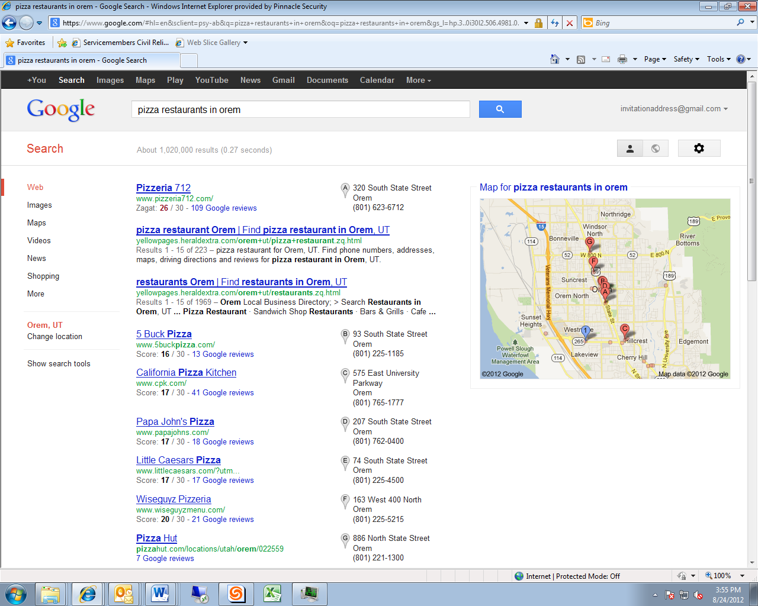  
  
**Building Your Google Places – Remember to Verify!**

Creating a Google Places page is fairly simple, but consistency in the name, phone number and address on the Places listing, your website and citations is imperative. It is also very important to verify your listing, which can be done by telephone, text or postcard.

**Address**

For best results, use the GoogleMaps address for your business. For example, if Google Maps lists you as 1120 North, but the street sign says Romney Lane, you should defer to the Google Maps address everywhere you list the address, including your website. Also, you must have an exact physical address because Google will not accept a P.O. box.

**Business Name**

Your business name should be listed as the exact business name, and not the URL. Also be sure not to include any keyword stuffing or adjectives unless it is part of your name. For example “Totally Awesome Computers” is fine because that is the actual business name, but not “Totally Awesome Wickham & Smith Attorney At Law,” because the adjectives are not in the actual business name. Also, your business has to be open and not under construction or virtual.

**Verify**

Verification is a vital step. Google’s purpose in creating Google Places is to assist the researcher in finding actual, open businesses. Verification is how Google verifies that your business is real.

**Steps for Building Google Places**  
1. Visit <http://www.google.com/places/>  
2. Click on “Add New Business”  
3. Fill out all information  
4. Be sure to add videos and images  
5. It is ABSOLUTELY CRITICAL that the name of the business, phone number, and address are the same on the website, Google Places listing and citations.  
6. Click to verify the business by SMS, phone or postcard.   
7. It is ABSOLUTELY CRITICAL you verify your listing.

**Businesses with One Location Only – Contact Information on Home Page**

If your business only has one location, your optimization will be increased if you include the name, address and phone number at the footer of the home page, in addition to any other pages, such as Contact Us. See the example below from [www.provolawncare.com](http://www.provolawncare.com):   
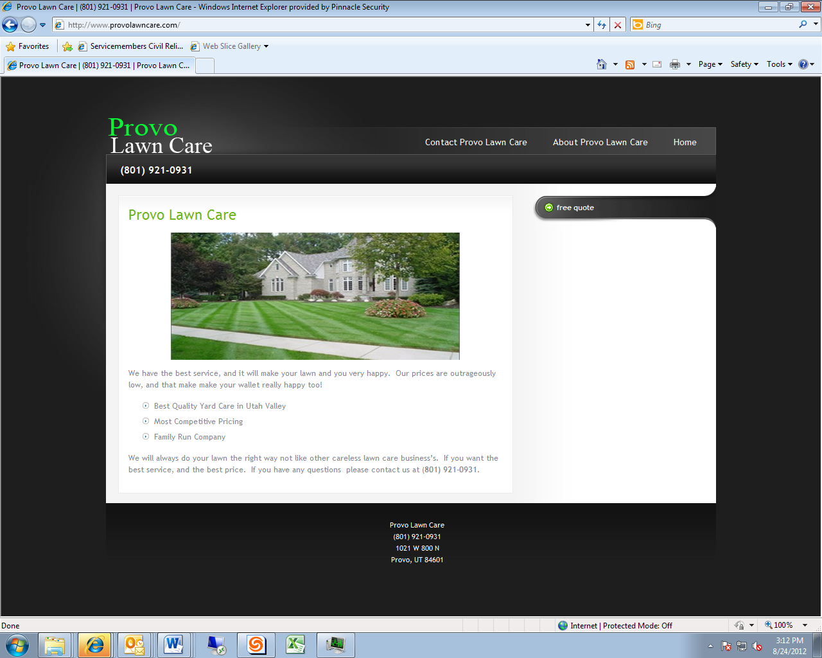

**Businesses with More than One Location**

If your business has more than one location, the author recommends having a different webpage for each location that then lists each one on Google Places. The webpage for each location needs to have its own address and telephone number. If you have only one business location that services multiple cities, then create just one listing for the central office and list different service areas.

**Citations for Google+ Local**

A citation is a listing of the name, address and phone number of your business on a third party’s website. Just as quality backlinks raise your ranking in organic listings, the number and consistency of citations can increase your placing in Google+ Local. Consistency is important because you can increase the trust in your website by showing that there are other third party sites that are citing the *exact* same address, phone number, and business name of your company. Volume is important because it shows the search engine that many sites are validating your contact information. The easiest way to get citations is by submitting your website to business directories, and there are many directories to use. The list below contains some suggestions, but for a more exhaustive list, perform a simple Google query for “best places for local business citations.”

**Where to Submit Your Website for Citations**  
1. local.botw.org  
    2. Yodle.com  
    3. Merchantcircle.com  
    4. Superpages.com  
    5. Dexknows.com  
    6. Local.com  
    7. Yellowbot.com  
    8. Yelp.com  
    9. Angieslist.com  
    10. Hotfrog.com

***Chapter Summary:***

1. ***A Google+ Local listing is advantageous because it displays above the organic listings and contains the name, address and phone number for your business.***
2. ***Make sure to use the exact same information everywhere and use an address that matches GoogleMaps.***
3. ***Do not forget to verify your listing.***
4. ***If you have just one location, list your address at the bottom of your home page.***
5. ***Get citations by listing in business directories. Citations should match your Google+ Local listing exactly.***
6. ***As with backlinks, higher quality citations are preferable, but you will not be penalized for listing in business directories.***

**Chapter 10: Search Engine Tools**

**Chapter Overview**

There are many tools to help you with your online marketing efforts. These will help you evaluate websites, so you know what websites are worth contacting with your guest blog posting requests. They will also help you evaluate your own website, so you can see how the online marketing work is improving the website’s authority.  There are a few tools I recommend when getting started. SEOMoz Pro requires the purchase of a membership, but it has a wide array of tools that are helpful for SEO research. For free tools, OpenSiteExplorer.org and SearchStatus are excellent for researching a website’s authority, and RankChecker and GoogleAdWords are helpful for keywords research.

**SEOMoz Pro Membership**

If you are serious about getting started with SEO, I strongly recommend purchasing a SEOMoz Pro membership, which is $99 a month at the time of publication of this guide. The SEOMoz membership will give you access to their entire suite of tools and allow you use of their campaign tracking software. This lets you track everything for up to five SEO campaigns including rankings for over 300 keywords per campaign  
  
**OpenSiteExplorer.org to Test Domain Authority**

OpenSiteExplorer.org provides information about domain authority on a 0-100 scale, where a high score indicates high authority. As discussed in detail in Chapter 5, domain authority indicates how much link juice a domain can pass to your site. You get 3 free queries a day with OpenSiteExplorer.  When you run a domain through the tool, you will see Domain Authority and Page Authority. Domain authority relates to the entire website and page authority relates to a particular page. In the example screenshot, the Domain Authority for dominos.com is 85.

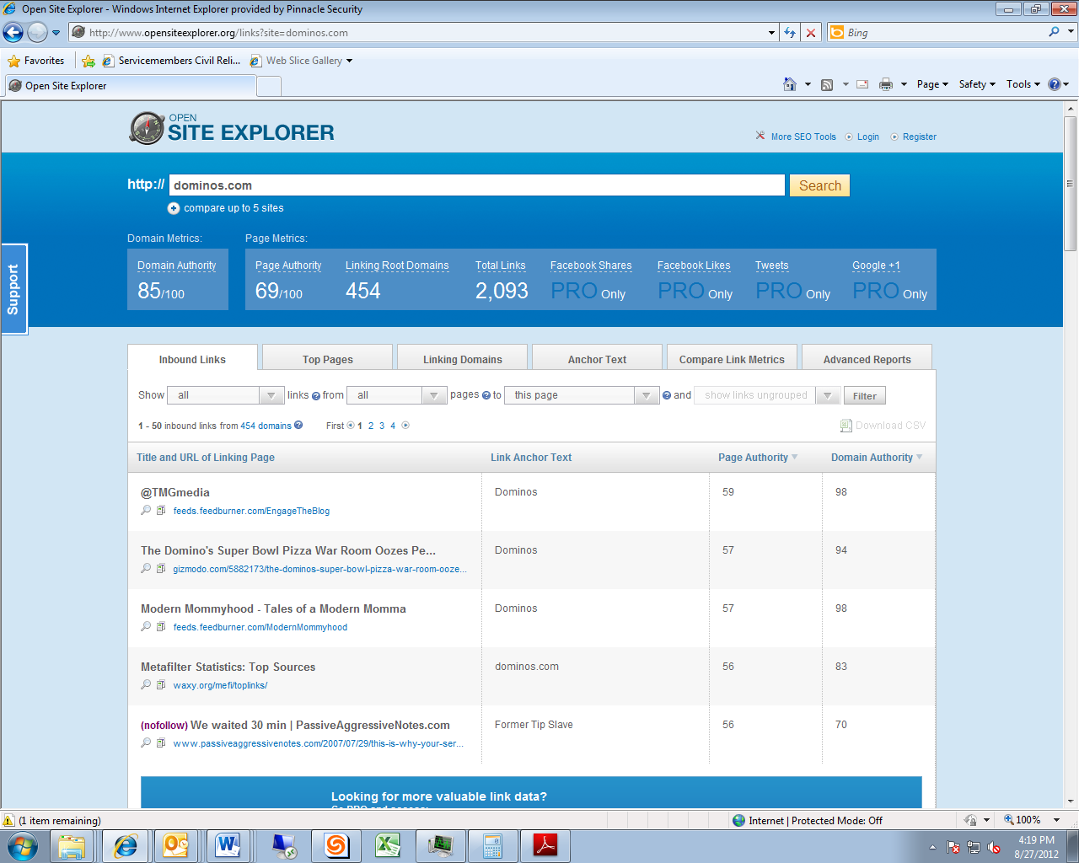

**SearchStatus Add-on for FireFox**

Another tool for evaluating a website’s authority is Search Status. This is a very popular SEO Add-on for FireFox. It is available for free download by going to <https://addons.mozilla.org/en-us/firefox/addon/searchstatus/>, or you can do a simple Google query to find where else you can download the software. The SearchStatus tool will show you the PageRank of the website you are browsing.

**RankChecker Add-on for FireFox**

This is a quick little tool you can get to help gather ranking data. You need to be careful because it isn’t always accurate. However, it can be used as a quick and simple tool to help evaluate where websites are ranking for sets of keywords. You can download it for free at <http://tools.seobook.com/firefox/rank-checker/>, or just do a simple Google query to find where else you can download the software. See Chapter 2 for more detailed information and examples about using RankChecker.

**Google Adwords Keyword Tool**

You can find this tool by visiting <http://adwords.google.com/o/KeywordTool>. This is going to be the tool you use for all keyword research. Use this tool to start evaluating which keywords to target for your campaign, with the goal of finding the words with the highest search volume and lowest competition.  You also want to make sure the keywords are very specific to your industry. It is critical the keyword brings the right type of user that will ultimately convert to a new customer. See Chapter 2 for more detailed information about keyword strategy and using the Adwords tool.

***Chapter Summary:***

1. ***The OpenSiteExplorer.org Domain Authority ranking and the SearchStatus ranking are tools to assess the link juice that a third party’s website can pass to yours.***
2. ***Rankchecker and Google Adwords are tools to assist you in assessing keyword search volume and competition as you design your keywords strategy.***

**Chapter 11: Measuring and Tracking Success**

**Chapter Overview**

Tracking your online marketing progress is extremely important for any SEO campaign. The normal metrics used to evaluate success are rankings, traffic, and revenue.  There are a few free tools that will be critical for evaluating your campaigns.  We recommend using Google Analytics for tracking traffic and user performance. It is free software that is very robust. If you are doing paid advertising with AdWords, you can also sync your analytics account. Tracking your website’s rankings is also very important to make sure you are making progress with your online marketing efforts. Gaining increased rankings is usually a critical element for obtaining increased traffic and ultimately more revenue. You have a few different options for tracking your website’s rankings. You can either do it manually with an Excel or Google spreadsheet or you can use a platform like SEOMoz. The important thing is that you are evaluating your website’s performance on a regular basis to make sure you are moving in the right direction.   
  
**Tracking Rankings for Keywords**

Tracking your rankings for keywords can be done in several ways. The most basic method is to use a spreadsheet.  This is where you will have the keyword cluster you are targeting with your SEO campaign. You will want to have a few different rows of data. The first will be keyword. Second will be the URL you are targeting for that keyword. The third will be the exact search volume. This will help you determine the priority of each keyword. The fourth column will be the starting rank of the keyword. That will be your baseline metric for evaluating the progress of your online marketing efforts.  The fifth column will be the date of when you are checking the rankings. You will just keep building out columns from there. My recommendation is to check the status of your keywords at least once a month. This will help you keep track of the progress you have made for each keyword phrase.  Below is an example of a typical keyword cluster with ranking data. You are going to want to build one of these clusters for all of your online marketing campaigns. This will help you when doing your link building work items because it will show you the URL you are targeting for each phrase and help you prioritize keywords.

**Keyword Cluster Example**  
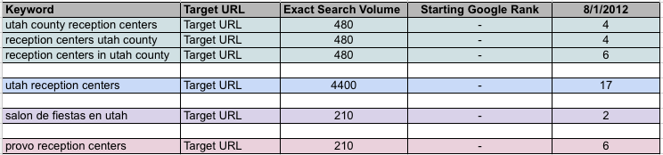  
**SEOMoz Pro Membership**

An alternative to manually tracking your rankings is to use the SeoMoz tool. An SEOMoz Pro membership allows you to evaluate up to 300 keywords per campaign. If you are investing a significant amount of money into your website, I strongly recommend purchasing an SEOMoz account. You can enter this to find out more information about SEOMoz’ program http://www.seomoz.org/plans

There are a few things to remember when checking the rankings of your website. Google is always trying to list the most accurate results pages to their users. Because of this, they have come up with serving personalized listing depended on your browsing history and geographical location.  While this is great for giving users what they want to see, it makes it very difficult for webmasters to see the accurate rankings of their websites.  There are a few things you can do to work around the personalized results pages.

**Google Incognito**

First, you are going to want to browse in Google Chrome for checking the rankings of your site. Chances are you have visited your website’s URL several times. This is telling Google that website is to your interest.  You need to get away from that personalization if we are going to get accurate rankings. There are a few easy things you can do to get non- personalized listings.

1. Go up to “File” in the Google Chrome menu bar.

2. Select “New Incognito Window”. This will open a new browser that has no personalization.

3. Make sure you aren’t logged into your Google account.

These steps will get you get set up with a Google Incognito window. This is the first and most obvious step for generating non personalized rankings. The next step is to make sure you are not getting results pages based on your geographical location. This will be most important for national type queries.

**Non Geo-Targeted Listings**

If you are checking the national rankings for one of your keywords, you need to make sure you change the geo-location of your query. We normally recommend you change this to a major metropolitan city.  If not, Google will give your website much better rankings because you are targeted to the city where you live. While this makes you happy that you are coming up at the top of the listings, it is not accurate to what everyone else in the country is seeing. You will need to change the location of the query to a major city.  You can see the geo-location of the query in the left hand sidebar of the Google results page.  As you can see in this example, the query is being targeted to Provo.  
  
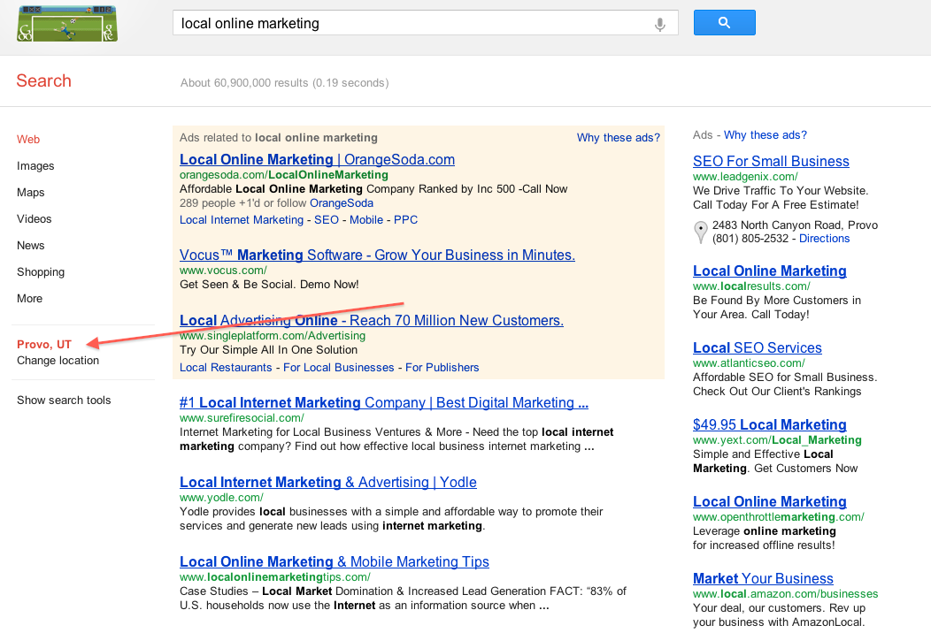  
  
**Tracking Traffic and Revenue**

Tracking rankings will always be a core part of any SEO campaign. While the ranking of a website has a strong correlation to the traffic and online conversions, it is not the most important metric. Traffic and revenue are even more important metrics because these relate to profit. In order to gather that data, you are going to need to use a tool like Google Analytics.  Please follow the instructions below for getting your website started with analytics.

**Implementation of Google Analytics**

Google Analytics is a very robust piece of software that can track a variety of metrics. Some companies will choose to go with a platform like Omniture for their analytics. This is normally when they have extremely complicated data that needs to be tracked and recorded in a very custom manner. Google Analytics usually has enough customization for 99% of small businesses.

Adding Google Analytics to your site is just a matter of including a short piece of JavaScript on each of your pages. Depending on the platform you are running, there are usually plugins that assist with getting this done. If there isn’t a plugin for your website’s platform, I recommend adding the code to the Header of the site’s code. This will make it so the code is dynamically added to each of your pages.  Google has a lot of support material to help users get analytics added to their site. I recommend looking at this page for getting started <http://support.google.com/googleanalytics/bin/answer.py?hl=en&answer=55488.>

**Compare UA Numbers to Ensure Google Analytics is Set Up Correctly**

After you add the Google Analytics tracking code to all of your pages, you need to check to make sure you did everything correctly. The easiest way is to look at the source code of a few of your pages.

1) Open your site in Firefox.

2) Press Ctl U to see the HTML.

3) Press Ctl F to open up a “find function in the browser.

4) Type “UA” in the finders bar (All Google Analytics have a unique UA number for each account.)

5) The UA number should match the account number in the Analytics account.

 Remember, in FireFox you can see the HTML of the page by pressing Ctrl U. After that, you are going to want to press Ctrl F. This will open up a “find” function in the browser.  Type “UA” in the finders bar. Below is an example of what you are looking for. The UA number should match the account number in the analytics account.

**Example of “find” function in source code for UA number:**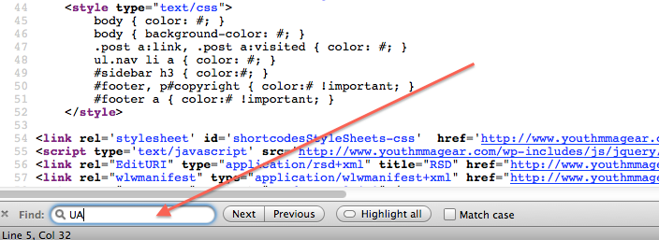

**Example of UA number in source code**.

As you can see, this shows the entire piece of tracking JavaScript. At the top, you can see the opening script tag <script type=text/javascript”>.  At the bottom, you can see the closing script tag </script>.

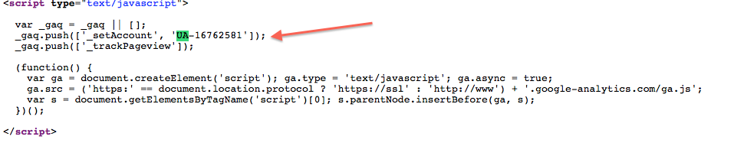

**Example of looking at website’s UA number in Google Analytics**

You will see this data right from the dashboard after you create your account. As you can see, this number matches the UA number from the source code in my site. This verifies that the page being tracked is set up correctly. You are going to want to spot check 5 or 6 pages on your site to make sure the UA number is correct. As I stated earlier, my recommendation is to stick the analytics tracking script in the header of the sites HTML.

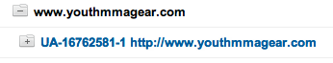  
  
  
  
***Chapter Summary:***

1. ***Rankings can be tracked manually or with the subscription tool, SEOmoz.***
2. ***If you are manually checking your ranking, make sure that your results are not skewed by your previous searches or your geographical location by using Google Incognito and by changing your search location to a large city.***
3. ***Google Analytics can help you track revenue and traffic.***
4. ***After implementing Google Analytics, confirm that you have it set up correctly by checking the UA numbers.***